**HOW TO PROPERLY CITE IMAGES IN MLA FORMAT**

**As with other citations in MLA format, citing images occurs in TWO PARTS:**

**PART 1: THE IN-TEXT CITATION**

When including images in a document, please use the following **general guidelines** for citing an image (including a painting, sculpture, or photograph):

1. Collect all your sources and record the information required for MLA documentation for the source medium of the illustration (e.g. print, Web, podcast).
2. Keep this information as you will need to record it on the Works Cited page. You will need to provide the artist's name, the work of art *italicized*, the date of creation, the institution and city where the work is housed. Follow this initial entry with the name of the Website in italics, and the date of access.

Labels, captions, and source information

[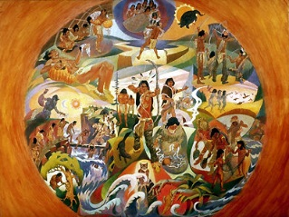](http://www.google.ca/url?sa=i&rct=j&q=&esrc=s&source=images&cd=&ved=2ahUKEwj-n_6rxMbZAhWO14MKHWufDQUQjRx6BAgAEAY&url=http://www.thecanadianencyclopedia.ca/en/article/religion-of-aboriginal-people/&psig=AOvVaw3GiQOeezsCzVrTxRXCBhNP&ust=1519835934841814) When illustrations or images appear directly embedded in the document, the

illustration label and number should always appear in two places:

1. the document’s main text (e.g. *see fig. 1*), and
2. near the illustration itself (*Fig. 1*).

In addition to the label and number (ie. *Fig.1*), the image must include a caption

and/or source information (work title), just like the image to the left.

Fig.1 Native Myths of the Afterlife

**PART 2: THE WORKS CITED PAGE**

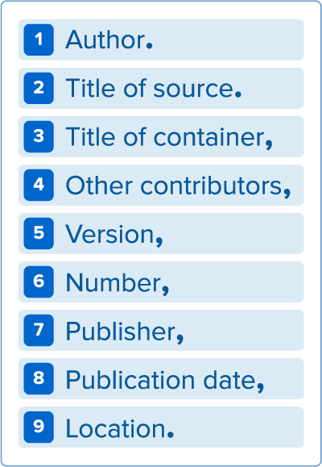Once you have embedded your images and labelled them properly within the text, you must also provide the specific details of your sources on the Works Cited page.

This information represents the **MLA core elements.** Include the information outlined above for an image, but format it using the punctuation in this diagram.Use this diagram when citing all other sources in this specific order, using the punctuation outlined.

**The following are examples of how images should be cited on a Works Cited page…..**

Goya, Francisco. *The Family of Charles IV*. 1800. Museo Nacional del Prado, Madrid. *Museo Nacional del Prado*, [www.museodelprado.es/en/the- collection/art-](http://www.museodelprado.es/en/the-%09collection/art-) work/the-family-of-carlos-iv/f47898fc-aa1c-48f6-a779-71759e417e74. Accessed 22 May 2006.

Klee, Paul. *Twittering Machine*. 1922. Museum of Modern Art, New York. *The Artchive*, [www.artchive.com/artchive/K/klee/twittering_machine.jpg.html](http://www.artchive.com/artchive/K/klee/twittering_machine.jpg.html). Accessed May 2006.

**If an image is only taken from an on-line website,** provide the name of the artist, the title of the work, and then follow the citation format for a website. If the work is posted via a username, use that username for the author.

Adams, Clifton R. “People relax beside a swimming pool at a country estate near Phoenix, Arizona, 1928.” *Found,* National Geographic Creative, 2 June 2016, natgeofound.tumblr.com/.