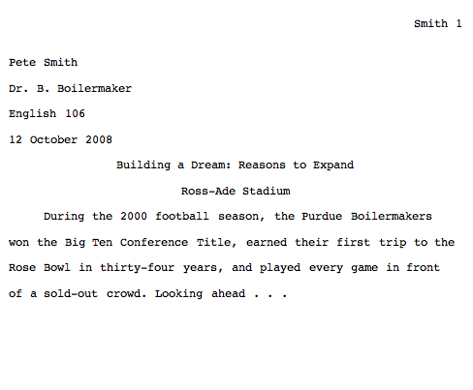**IN MLA FORMAT, THE FIRST PAGE OF YOUR PAPER SHOULD LOOK LIKE THIS.**

**THE ENTIRE DOCUMENT SHOULD BE DOUBLE-SPACED, TYPED USING 12 PT. TNR, ARIAL OR TAHOMA FONT.**

**SET MARGINS TO 1” AND INCLUDE YOUR HEADER ON ALL PAGES.**

**INDENT EACH PARAGRAPH (HIT TAB).**

**TITLES OF CONTAINERS (see below) SHOULD BE ITALICIZED EACH TIME THEY ARE USED.**

**ALL SOURCES THAT ARE REFERRED TO IN THE DOCUMENT MUST BE CREDITED USING PARENTHETICAL DOCUMENTATION IN-TEXT AND THEN IN THE *WORKS CITED.***

**FOR EXAMPLE, THE IN-TEXT CITATION:**

Romantic poetry is characterized by the “spontaneous overflow of powerful feelings” (Wordsworth 263).

**CORRESPONDING WORKS CITED ENTRY:**

Wordsworth, William. *Lyrical Ballads.* Oxford UP, 1967, pp.263. Print.

**SHORT QUOTATIONS** constitute FOUR lines typed or fewer, are introduced with a comma, are sandwiched by opening and closing quotation marks, and are embedded in your paragraphs. The in-text citation appears immediately afterwards with closing punctuation outside the parenthesis.

**LONG QUOTATIONS** are longer than FOUR lines typed, are introduced with a colon and are “blocked” from your paragraph by indenting the entire quotation 10 spaces (2 tabs) without quotation marks. The in-text citation appears immediately after the closing punctuation after the quotation.

**THE WORKS CITED PAGE – 9TH EDITION**

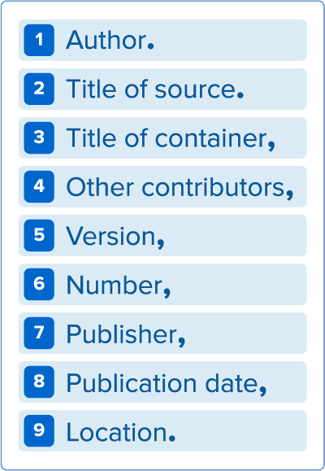In the new model, the work’s publication format is not considered. Instead of asking, “How do I cite a book [or dvd or web page]?” the writer creates an entry by consulting the MLA’s list of **core elements—facts common to most works**—which are assembled in a specific order, using the punctuation outlined below. However, not *all* the elements apply to all works.

*the author of the resource referenced (last name, first name.)

*the title of self-contained source, or title of a part of a larger whole

*the title of the larger whole that “contains” the source

*refers to editors, translators, adaptors, illustrators, etc.

*if the source was released in more than one form or edition

*if the source is issued in multiple volumes or issues

*organization responsible for producing the source

*either the print or online publication date, depending on the source

*refers to page numbers for print sources and URL’s for online sources

**PLEASE NOTE: THE TITLE OF THE CONTAINER SHOULD BE IN ITALICS, WHILE THE TITLE OF A SOURCE, IF IT IS WITHIN A CONTAINER, IS IN QUOTATION MARKS. IF THE TITLE OF THE SOURCE IS SELF-CONTAINED, IT IS IN ITALICS. *BE SURE TO INCLUDE THE DATE ACCESSED AT THE END FOR ONLINE WORKS\***

Below are some possible entries and how they should appear on a Works Cited page; a song, a novel, an online article, a short story, and a website (in that order):

Giannakopoulos 5

Works Cited

Beyonce. “Pray You Catch Me.” *Lemonade,* Parkwood Entertainment,

2016, [www.beyonce.com/album/lemonade-visual-album/](http://www.beyonce.com/album/lemonade-visual-album/). Accessed 17 March

2009.

Henley, Patricia. *The Hummingbird House.* MacMurray, 1999.

Hollmichael, Stefanie. “The Reading Brain: Differences between Digital and Print.”

*So Many Books*, 25 Apr.2013, somanybooksblog.com/2013/04/25/the-reading- brain-differences-between-digital-and-print/. Accessed 20 March 2020.

Kincaid, Jamaica. “Girl.” *The Vintage Book of Contemporary American*

*Short Stories,* edited by Tobias Wolff, Vintage, 1994, pp.306-07.

Lundman, Susan. “How to Make Vegetarian Chili.” *eHow,*

[www.ehow.com/how*_*10727_make-vegetarian-chile.html](http://www.ehow.com/how_10727_make-vegetarian-chile.html). Accessed 15

March 2020.

**A MORE THOROUGH GUIDE CAN BE FOUND ON THE IONA WEBSITE**

**FOR THE COMPLETE GUIDE, GO TO: https://owl.english.purdue.edu/owl/resource/747/01/**

HELPFUL ONLINE SOURCES AVAILABLE THROUGH OUR SCHOOL’S WEBSITE

**FOR BRITANNICA ONLINE:** 1. Go to the Iona website 2. Find the ‘Learning’ heading on the teal bar and select ‘Library’ from the dropdown menu 3. Scroll down until you find Britannica Online Reference Centreand click on it4. Select ‘high school’ and type in your choices/subject 5. 4. Click on the link icon and sign in with the Username: Ionacss, and Password: library

**FOR ELECTRONIC RESOURCES:** 1. Go to the Iona website 2. Select ‘Library Catalogue’ from the top black bar 3. Select ‘All E-Resources’ from the search bar 4. Type in your subject area or select from the list provided

**FOR E-BOOKS IN OUR LIBRARY:** 1. Go to the Iona website2. Select ‘Library Catalogue’ from the top black bar3. Type in your subject under ‘Quick Search’ and search it as a ‘subject’

**To Access GALE from home: username is your student number; password is Trillum**